**Topic:** Heron and the Great Theorem, Formula for Triangular Area

**Notes on Topic:**

The final classical mathematician is from Alexandria

In some books he is referred to as Hero

There is very little known on the personal life of Heron, there is some debate over the century he was even alive

Saving the detective work to the professionals, we will assume he was living around 75 AD

Although there is little known of his personal life, there is an astounding amount regarding his mathematics

His interests tended to be practical rather than theoretical; dealing with mechanics, engineering and measurement

His interests really emphasize the contrast between Greek and Roman mathematics

Heron explains how to dig tunnels under mountains and how to measure the amount of water flowing from a spring

An example of a mundane problem he would solve: *“Why does a stick break sooner when one puts one’s knees against it in the middle?”*

*“Why do people use pincers rather than the hand to draw a tooth?”*

Heron’s proposition regarding the area of a triangle certainly had practical intent, but his proof displays perfectly his strengths in abstract geometry.

**The Great Theorem:**

This may seem trivial given the simplicity of the triangle’s modern formula A = ½bh, but when given three sides of a triangle, the height is not necessarily supplied.

It is interesting to note that because of SSS congruence (Euclid, *Elements,* I.8) any other triangle given these three measurement must inherently have the same area as the aforementioned triangle

So if given three sides, we know there is one and only one possible value for area.

Thus establishing the uniqueness of a triangle’s area.

How can we find the value?

It is the same formula today as was used nearly 2000 years ago.

, the semi-perimeter

This formula is not only not intuitive, but also seems a little advanced for this era with the use of semi-perimeter and square roots.

Heron’s proof is extremely surprising and ingenious.

Heron’s theorem implies that the area can be found only knowing the lengths of the sides.

He uses five propositions to build his argument, in-part thanks to Euclid.

**Proposition 1:** The bisectors of the angle of a triangle meet at a point that is center of the triangle’s inscribed circle

* From *Elements,* Prop IV.4

**Proposition 2:** In a right triangle, if a perpendicular is drawn from the right angle to the base, the triangles on each side of it are similar to the whole triangle and to one another

* From *Elements*, Prop VI.8

**Proposition 3:** In a right triangle, the midpoint of the hypotenuse is equidistant from the three vertices.

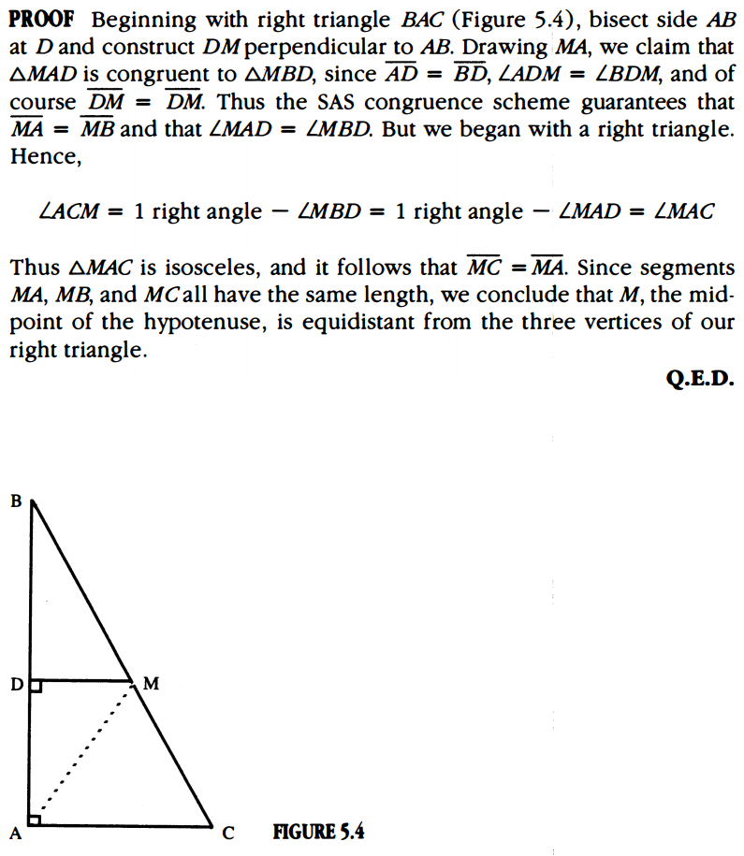

**Proposition 4:** If AHBO is a quadrilateral with diagonals AB and OH, and if <HAB and <HOB are right angles, then a circle can be drawn passing through the vertices A, O, B, H

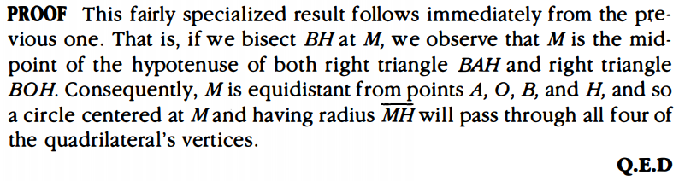

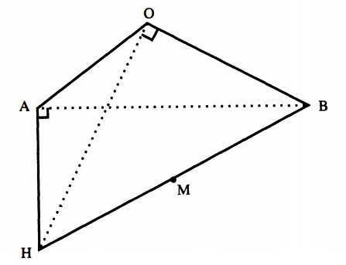

**Proposition 5:** The opposite angles of a cyclic quadrilateral sum to two right angles.

* From *Elements,* III.22, proof given in Chapter 3

**The Final Result:**

**Theorem:** For a triangle having three sides of length a, b, c and area K, we have

,

where s = ½ (a + b + c) is the triangle's semi-perimeter.

**Summary of Proof:** Let ABC be an arbitrary triangle so that side AB is at least as long as the other two. To make Heron’s argument flow smoothly, we shall divide it into its three main parts.

**Part A:** Heron surprisingly starts by inscribing a circle into a triangle, (uses proposition 1). The angle bisectors of ABC now establish three separate triangles, with the height of the triangles given (since the height is the radius of the inscribed circle).

* From there the area of the three inner triangles can be found, so the three areas are given, ½ ar, ½ br, ½ cr.
* From there K= ½ ar + ½ br+½ cr = = rs

**Part B:** Notice, by inscribing the circle we already have bisected the vertex angles of the triangle, therefore establishing three sets of congruent triangles (referring to Fig 5.6/7).

Following, Euclid’s Prop I.26.

By CPCTC we have,

AD=AF, BD=BE, and CE=CF

While <AOD = <AOF, <BOD = <BOE, and <COE = <COF

At this point, Heron extended AB to a point G, where AG=CE he then argued,

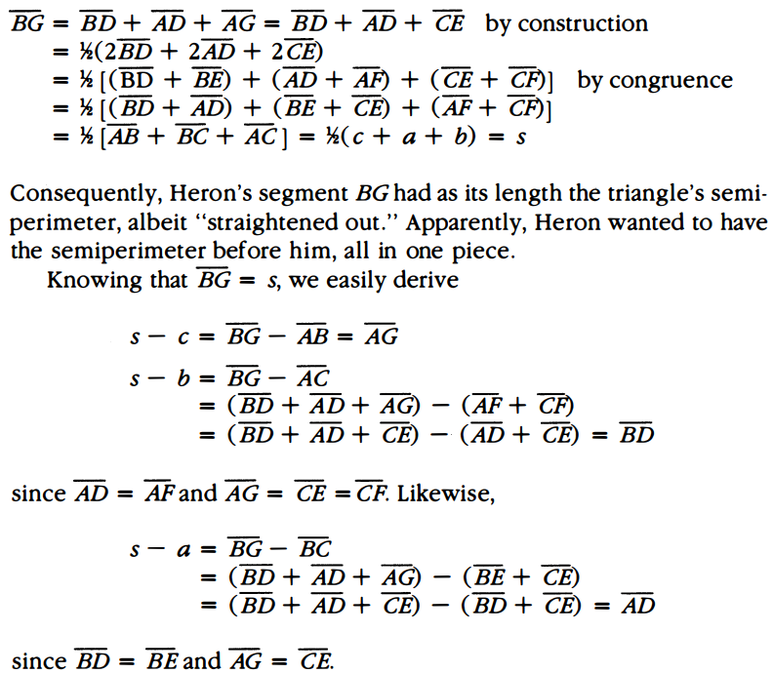

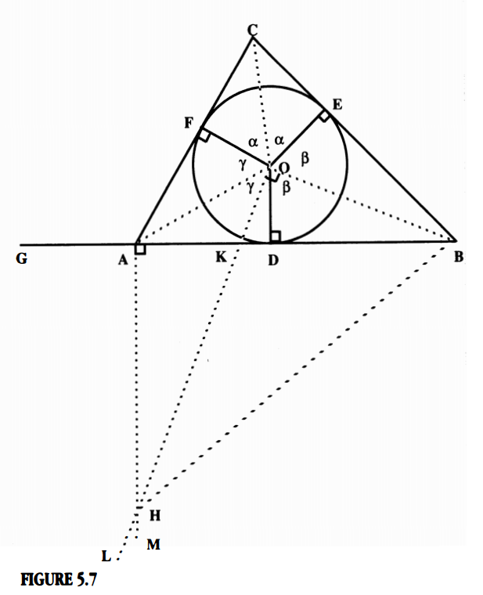

**Part C:** Notice, Quadrilateral AHBO is a cyclic quadrilateral (by Prop 4) and therefore (by Prop 5) we know that opposite angles sum to two right angles.

Heron then argues

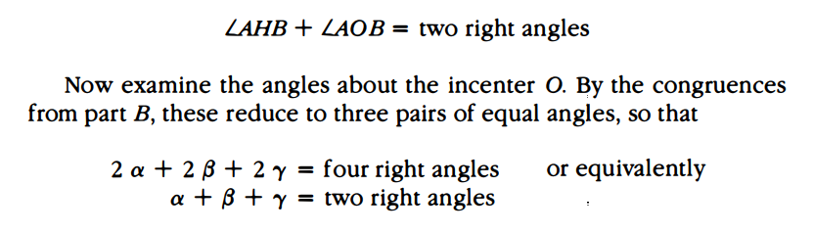

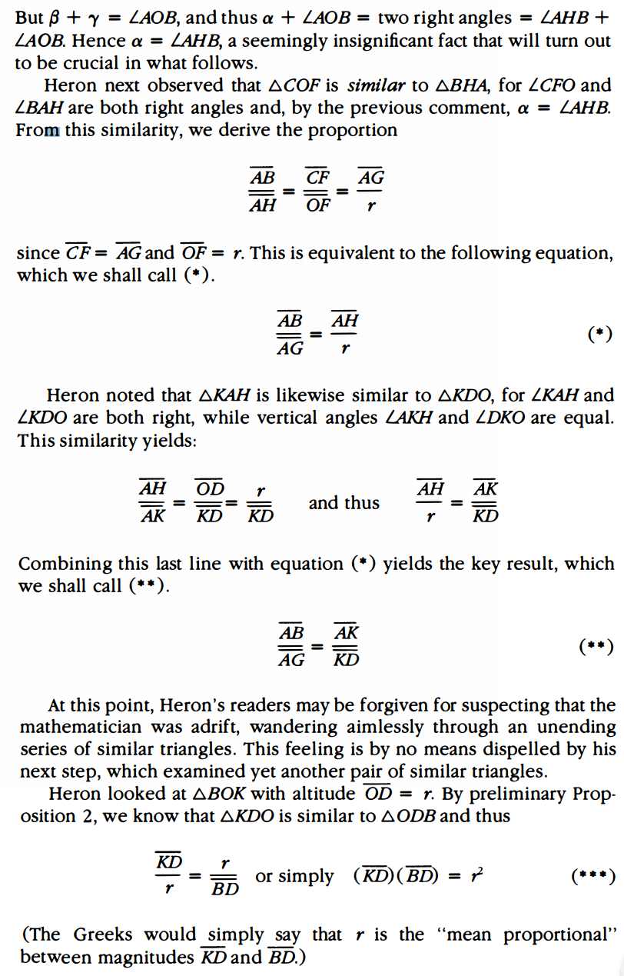

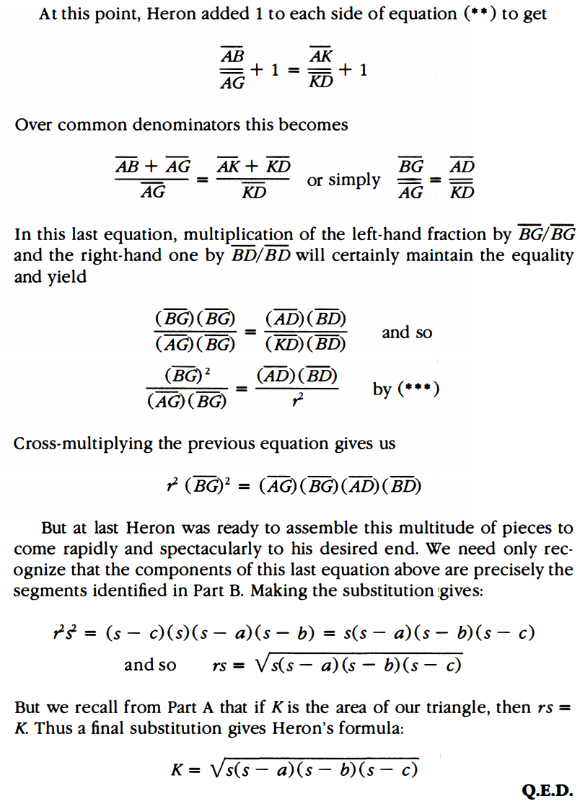

Thus ends one of the cleverest proofs of elementary algebra. Certainly the most convoluted we have encountered. Throughout the argument, Heron has a way of making us think we are reaching a conclusion, then turning a corner to keep us on our toes.

**Additional Suggested Reading**: Details of Heron’s argument, Epilogue, Chapter 5

**Assignment:** Homework 4: 68, 69, 72, 74